MAKING HISTORY TODAY
The Han-Net (a Houston area activist network) archives show that on June 3, 1999, Rick Hurt stated: "Montrose includes the Museum District…. where is the Gay (glbtf) Museum?” From that one comment began a discussion about why there was not one, and on July 17, 1999, 13 people came together in a small meeting room at the Montrose Public Library and so began the seed that would become GCAM.

GIVING of YOURSELF
If you are interested in donating your entire collection, or even just a portion of it, there are several ways to do that.
- Permanent Donation - giving ownership of your collection to GCAM for preservation and/or display. A release date for sensitive materials can be requested.
- Permanent Loan - maintaining ownership of your collection, but letting us permanently display and/or house it until such time as you want it back.
- Temporary Loan - allowing us to display your collection for a specific length of time (or a specific display).
- Bequest - Making a temporary or permanent loan of your collection with the understanding that at your passing, ownership goes to GCAM or simply letting GCAM inventory your collection and marking it with appropriate language in your will so that ownership goes to GCAM.

Any of these methods allow GCAM and the world access to your history - and therefore OUR history. Become a part of GCAM today, by sharing your information with us.

Personal stories are always useful in helping set the background for a particular display and in maintaining another segment of history. E-mail us yours today (info@gcam.org).
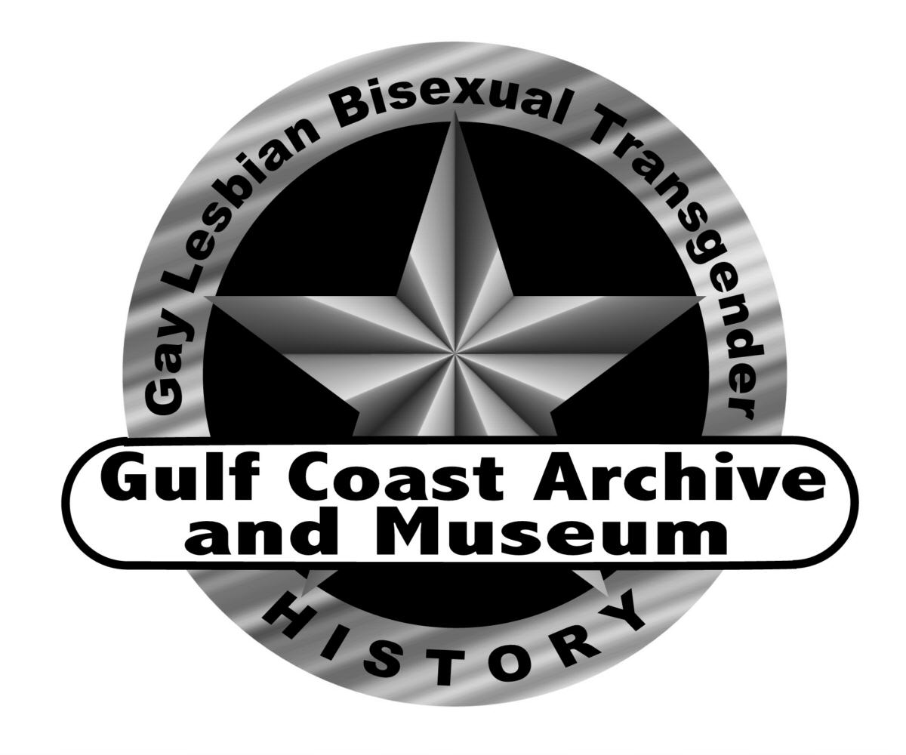
WISH LIST
As with any not-for-profit corporation, there are always things that we can use. If you have any of these items "just laying around" and no longer have any use or the space for them, please consider sending them our way.

- Safe places for more Satellite Exhibits
- Monies or space for on-going storage
- Wall Mounted locking Display Cases
- Blank CD Roms
- Shelving
- Frames for pictures and posters
- Mannequins
- Light Table
- Volunteers for Cataloging
- Collections - Your Stuff

About GCAM
Gulf Coast Archive and Museum of Gay, Lesbian, Bisexual and Transgender History, Inc. is a Texas non-profit corporation recognized by the Internal Revenue Service as a 501(c)3 organization.

Individual membership in the corporation is by payment of annual dues ($25), Dues are prorated quarterly. Payment schedules are available, as well as scholarships, for those unable to pay full dues. Payment schedules can be established or scholarships requested by contacting any executive officer. Instead of an individual membership, a person may elect to be a sustaining member ($25/month). Corporate memberships are $100, are granted a single voting privilege, & will be listed in our PR.

The executive officers and the membership are advised by an Advisory Board (consisting of three or more advisors in archival fields) on matters of archival importance. Additionally, a Board of Governors consisting of nine members, advises the executive officers and the membership regarding all other roles of the corporation.
Gulf Coast Archive
and Museum
of Gay, Lesbian, Bisexual
and Transgender History, Inc.

The Gulf Coast Archive and Museum was formed to collect, preserve and provide access to historical items from our community. We also encourage education and research, and to that end, sponsor meetings for the communication and display of collected materials.

Museum items can be found on display at the GLBT Community Center. Soon we will have an exhibit at the new Montrose Guest House as well. Our goal at this time is to have many small satellite exhibits for the community to see, Our web presence is growing, and hope to be able to include some or all of our history online.

COLLECTIONS
We are interested in finding those collections which may be donated to us. If you have old publications, documents from other organizations, trophies, photographs, tape recordings, or even erotica that you would consider donating to us, let us know! Keep in mind that a single piece of correspondence, a photograph or other memorabilia can be very important to the organization and the community.
THINGS WE COLLECT

We will collect the following materials with GLBT content:
-------------------------------------------------------------------------------------------------------------------------------------------------------
Gulf Coast Archive and Museum of GLBT History, Inc., P.O. Box 130192, Houston, TX 77219-0192
YES. I want to help GCAM!
__ I want to become a member - Individual $25/year (prorated quarterly). Corporate $100/year.
__ I want to make a donation of: __ $1000 __ $500 __ $250 __ $100 __ $50 __ $25 __ Other: _______
__ I would like to know more. Please call me. _______________
__ I would like to volunteer: Cataloging: ______ Board Member: ______ Other: ______
__ I need someone to speak to my group.
__ I have things to donate.

Name: _______________________________________________

Street: _______________________________________________

City: _________________________________ State: ____ Zip: __________ Phone: ________________

E-Mail Address: _____________________________ Birthday: ____ / ____ 3/06
- Library Materials and Books
- Correspondence
- International Publications (any language)
- Non-GLBT Periodicals (with GLBT content)
- Legal Erotica
- Periodicals
- Erotic Novels
- Audiovisual Materials (incl. antique formats)
- Music
- Photographs
- Southern Subcultural Periodicals
- Personal Scrapbooks
- Games, Puzzles, Toys and Collectibles
- Plaques, Award and Trophies
- Buttons, Matchbooks, Jewelry, Stickers
- Imprinted Clothing
- Banners and Flags
- Costumes, whole or partial
- Theatre Programs
- Calendars and Posters
- Greeting Cards, Postcards and Stationary
- Group/Organizational Colors
- and probably even more.... ask us.

THE INTERNET
One of the places we hope we can have a major presence is on the internet. Much of our history can be digitized, and as such, be available on the internet. Paper documents, photographs and recordings (audio and video) can all be digitized. Through this process, these artifacts can not only be preserved, but also made available to a much wider spectrum of people than we can hope to reach with just a physical museum. Our internet address is easy to remember: http://gcam.org. Tell your friends!

We have a listserv to communicate with our members, as well as persons who are interested in what is going on! To join, send an email to gcam-subscribe@yahoogroups.com.

WE NEED YOU!
We are looking for new members. We need volunteers who are willing to do cataloging of collections, help plan & execute events, or even serving on our Board of Governors.

We want and need your financial support. Our giving levels are:
- Tiara $5000
- Trophy $1000
- Costume $500
- Photograph $250
- Letter $100
Contributions at these levels will be acknowledged on our web page. We encourage organizations, as well as individuals, to contribute.

WHY WAIT?
JOIN TODAY!
Our annual dues are only $25, and as a member, you will be a part of this momentous project as we move forward in this historic endeavor. Won't you please join today?

If you need more information, you can call us at 713-692-8735 or e-mail us at info@gcam.org.

