--------------------------------------------------------------------------------------------------------------------------------------------------------------
Gulf Coast Archive and Museum for GLBT, Inc., 2507 Capitol Street, Houston, TX 77003, 713-227-5973
YES. I want to help the Gulf Coast Archive and Museum for Gay, Lesbian, Bisexual and Transgender, Inc.!
__ I want to become a member ($25/year - $25 1st qtr, $18.75 2nd, $12.50 3rd, $31.25 4th and next year).
__ I want to make a donation of: __ $50 __ $100 __ $500 __ Other: _______

__ I would like to know more. Please call me. _______________
__ I would like to know more about volunteering. Cataloging: _____ Board Member: ______ Other: ______

Name: _______________________________________________ E-mail: __________________________

Street: _______________________________________________

C City: _________________________________ State: ____ Zip: __________ Phone: ________________
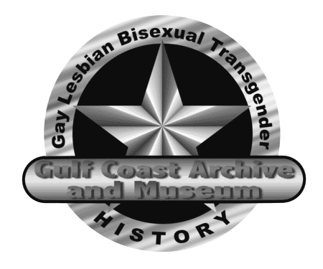

Gulf Coast Archive
and Museum
for Gay, Lesbian, Bisexual
and Transgender, Inc.

The Gulf Coast Archive and Museum was formed to collect, preserve and provide access to historical items from the our community. We also encourage education and research, and to that end sponsor meetings for the communication and display of collected materials.

It is our intended hope to raise enough funds to create not just an archive, but also a museum with probably weekend hours where people can get hands on information about our history. At the same time, we hope to have a web presence, and be able to include some of that history online.

COLLECTIONS
If you have old publications, documents from other organizations, trophies, photographs, videos, tape recordings, costumes, play bills, letters, t-shirts or even pornography that you would consider donating to us, let us know! If you are aware of a collection that is in danger of destruction, let us know that as well. Although our focus is the Gulf Coast Area, so much of our history is national and global, we will take anything so long as it is connected to GLBT.

THE INTERNET
One of the places we hope we can make a large presence is on the internet. Much of our history can be digitized, and as such, be available on the internet. Paper documents, photographs and recordings (audio and video) can all be digitized. As such, they can not only be preserved, but also be made available to an even much wider spectrum of people that we can hope to reach with a physical museum. Our internet address is easy to remember : http://www.gcam.org. Tell your friends!

We have a listserv to communicate with our members, as well as persons who are interested in what is going on! To join the listserv, visit http://www.egroups.com/subscribe/gca or send a message to gca-subscribe@egroups.com.

THE MUSEUM
Currently, the museum is open by appointment only in a temporary space generously donated to us. However, we will NOT be able to stay in this space forever, and our long term goal is to have our own facility in the Houston area. As such, we are looking for funds to facilitate that possibility.

WE NEED YOU!
We are looking for new members. We need people who are willing to work in the organization, cataloging our archives, volunteering specific hours for the museum to function on a set schedule or perhaps even serving on our Board of Governors.

WHY WAIT?
JOIN TODAY!
Our annual dues are only $25 prorated quarterly, and that membership will keep you abreast and make you a part of what we are doing as we move forward with this important and historic organization. Won't you please join today?

